OBJECT ORIENTED PROGRAMMING PROJECT

LIBRARY MANAGEMENT SYSTEM REPORT



Created by:

1. Berliano Putra Kukuh Wibowo (373)

2. Firdaus Firmansyah (039)

3. Muhammad Kharisma Aditya Putra (200)

UNIVERSITAS MUHAMMADIYAH MALANG

ENGINEERING FACULTY

INFORMATICS DEPARTMENT

1. BACKGROUND

In this report we will discuss about “*Library Management System*”, why it is crucial to have, it’s architecture, how it work and how the user can use manage their library like borrowing books, returning it or checking the availability of the books.   
  
 Traditional library management system relies on manual bookkeeping that are prone to inconsistency, error and other problem and how tasking it is to the staff that has to manually track borrowed books, their due date and the fine that comes with returning the books late, in the hope of making it easier is why this application was created.

1. OBJECTIVE

The objective of this task was to make a library management system using Java-based desktop application using OOP principles, while also implementing a modular architecture to separate logic or MVC pattern while providing key library features like:

1. Book Management (CRUD)
2. Member Registration
3. Borrowing and returning books
4. SYSTEM ARCHITECTURE

The system architecture of the program consist of 3 parts which are :

1. **Model (Data),** it is used to store data and handle logic (e.g., stock updates, borrow records).
2. **View (User Interface)**, User Interface is what we see when we use the application like the login page and borrowing page for Normal User, also managing books and user’s data for Admin.
3. **Controller (Logic),** Controller is for processing actions, for example processing user login is processed by UserController and BookController is for managing stock changes, how many book are available to borrow.
4. CLASS DIAGRAM

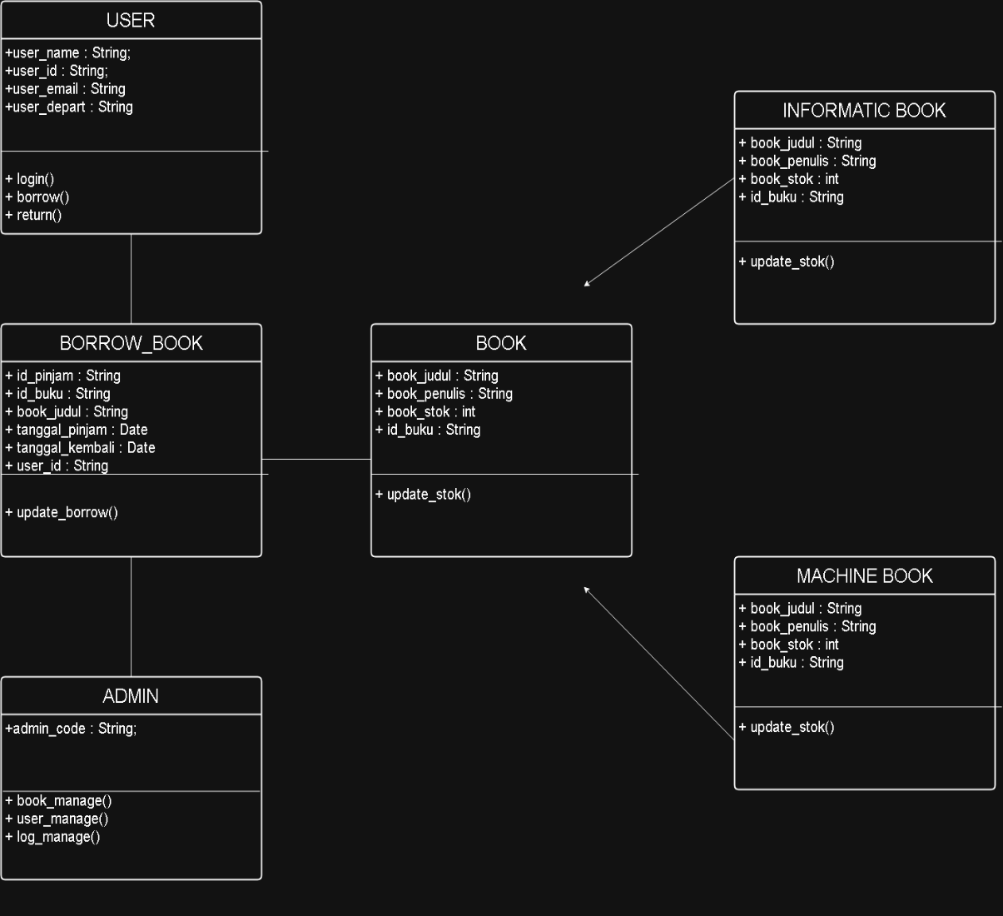

* In the class diagram above, the classes and their related attributes are shown in relation to one another. The USER and ADMIN classes represent the individuals who operate the program, with user_id and admin_code serving as credentials to access the system.
* The BOOK class functions as the parent class for INFORMATIK_BOOK and MACHINE_BOOK, with id_buku (book ID) acting as the anchor for the borrowing and returning process.
* The BORROW_BOOK class manages the book borrowing and returning activities by referencing id_buku from the BOOK class and id_user as the identifier of the user borrowing the book. In this class, the stock count in the BOOK class is reduced, and the attributes tanggalPinjam (borrow date) and tanggalKembali (return date) are added to indicate the borrowing period.
* The ADMIN class has access to all other classes, allowing administrators the freedom to add or remove books, view user data, and monitor the borrowing history.

1. FLOWCHART

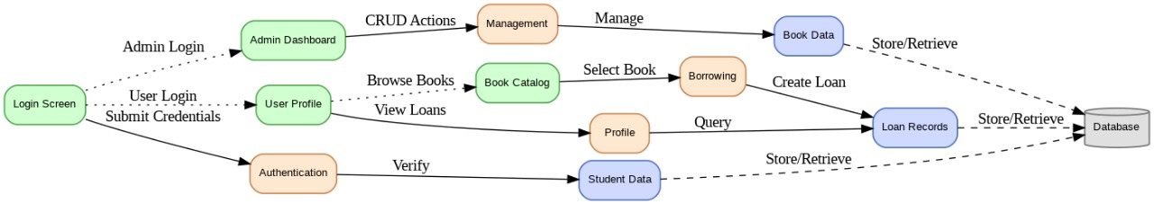

In the flowchart above it shows how the program works, how different component interact with each other.

1. **USER INSTRUCTION**

Now we are at the last part of the report which is the User Instruction, it tell the user on how to use the application. Below is how the user can use the application,

1. Log in to the library system using your registered student ID (NIM).

(If you haven’t registered yet, you can do so by clicking the “Register” button.)

2. On the profile page after logging in, you will see your personal information and a table displaying the books you are currently borrowing.

(If you haven’t borrowed any books, the table will appear empty.)

3. To borrow a book, click the “Pinjam Buku” button to enter the book catalog menu.

4. In the book catalog, there is a search bar to find books by title based on the keywords you enter, along with a table listing all books available in the library system.

5. To borrow a book, click the “Pinjam” button in the table. The borrowed book will automatically appear in the book table on your profile page.

6. To return a book, click the “Kembalikan” button. The system will remove the returned book from the book table display.

7. Click the “Keluar” button to exit your profile and return to the login menu.